Given a binary tree where node values are digits from 1 to 9. A path in the binary tree is said to be **pseudo-palindromic** if at least one permutation of the node values in the path is a palindrome.

*Return the number of* ***pseudo-palindromic*** *paths going from the root node to leaf nodes.*

**Example 1:**

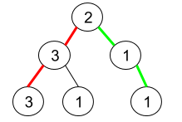

Input: root = [2,3,1,3,1,null,1]  
Output: 2   
Explanation: The figure above represents the given binary tree. There are three paths going from the root node to leaf nodes: the red path [2,3,3], the green path [2,1,1], and the path [2,3,1]. Among these paths only red path and green path are pseudo-palindromic paths since the red path [2,3,3] can be rearranged in [3,2,3] (palindrome) and the green path [2,1,1] can be rearranged in [1,2,1] (palindrome).

**Example 2:**

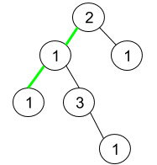

Input: root = [2,1,1,1,3,null,null,null,null,null,1]  
Output: 1   
Explanation: The figure above represents the given binary tree. There are three paths going from the root node to leaf nodes: the green path [2,1,1], the path [2,1,3,1], and the path [2,1]. Among these paths only the green path is pseudo-palindromic since [2,1,1] can be rearranged in [1,2,1] (palindrome).

**Example 3:**

Input: root = [9]  
Output: 1

**Constraints:**

* The number of nodes in the tree is in the range [1, 105].
* 1 <= Node.val <= 9